Pipeline assignment 2

1. Create 2 ec2 instances (one master and one slave)
2. Login master instance
3. Then install java and Apache tomcat install Jenkins

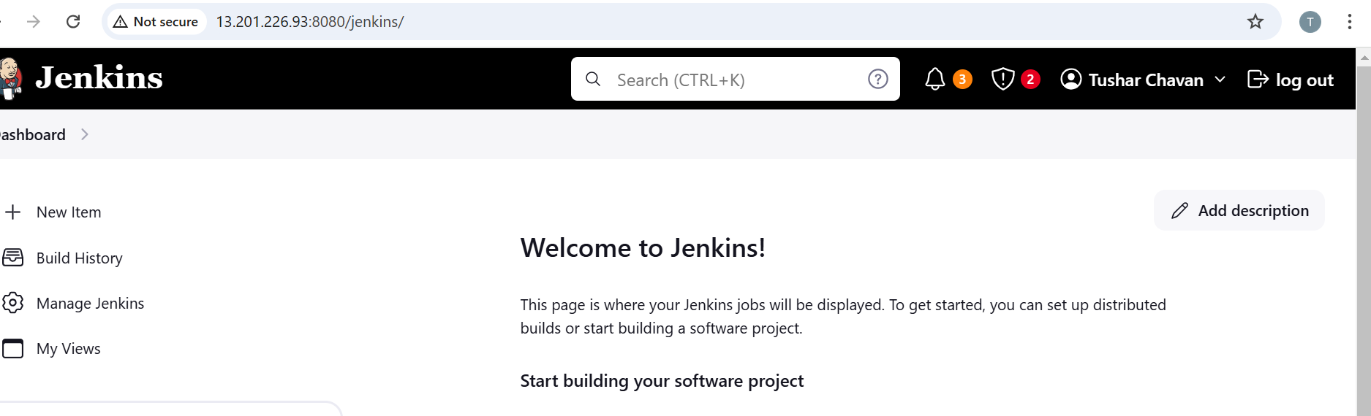

1. Login slave and then install java and Apache tomcat
2. Create one folder like Jenkins-slave and give permission that folder

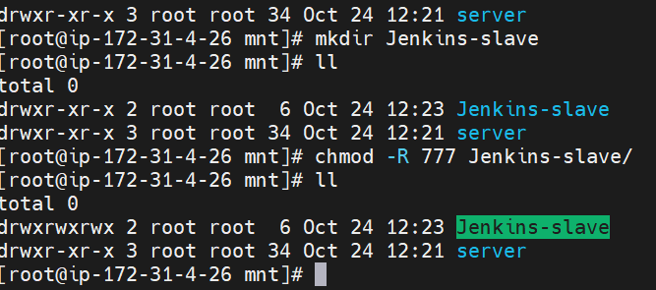

1. Go to Jenkins and configure the slave

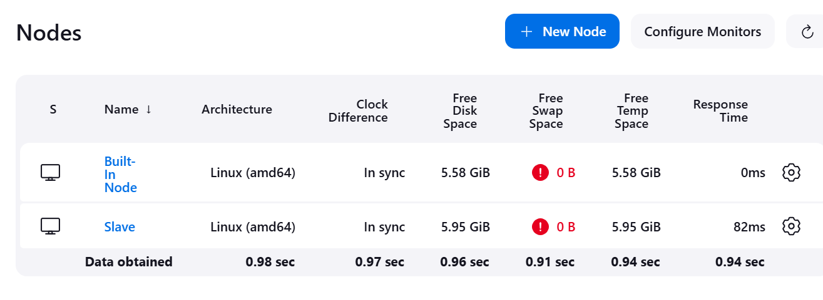

1. on slave install maven

wget <https://dlcdn.apache.org/maven/maven-3/3.9.9/binaries/apache-maven-3.9.9-bin.zip>

set the maven /root/.bash_profile 🡪 export PATH="/mnt/apache-maven-3.9.9/bin:$PATH"

1. create Pipeline 🡪
2. pipeline{
3. agent{
4. label {
5. label "Slave"
6. }
7. }
8. stages{
9. stage("clone github"){
10. steps{
11. sh '''
12. cd /mnt
13. sudo rm -rf loginwebapp
14. sudo git clone https://github.com/jidnyasactc/loginwebapp.git
15. '''
16. }
17. }
18. stage("maven install"){
19. steps{
21. sh '''
22. cd /mnt/loginwebapp/
23. sudo chmod -R 777 /mnt/loginwebapp/
24. export PATH="/mnt/apache-maven-3.9.9/bin:$PATH"
25. mvn clean install
26. '''
27. }
28. }
29. stage("deploy"){
30. steps{
31. sh '''
32. cp /mnt/loginwebapp/target/LoginWebApp.war /mnt/server/apache-tomcat-9.0.96/webapps
33. '''
34. }
35. }
36. }
37. }

9. then build now and check output

Started by user [Tushar Chavan](http://35.154.243.246:8080/jenkins/user/412tushar)

[Pipeline] Start of Pipeline

[Pipeline] node

Running on [Slave](http://35.154.243.246:8080/jenkins/computer/Slave/) in /mnt/Jenkins-slave/workspace/Assignment-2

[Pipeline] {

[Pipeline] stage

[Pipeline] { (clone github)

[Pipeline] sh

+ cd /mnt

+ sudo rm -rf loginwebapp

+ sudo git clone <https://github.com/jidnyasactc/loginwebapp.git>

Cloning into 'loginwebapp'...

[Pipeline] }

[Pipeline] // stage

[Pipeline] stage

[Pipeline] { (maven install)

[Pipeline] sh

+ cd /mnt/loginwebapp/

+ sudo chmod -R 777 /mnt/loginwebapp/

+ export PATH=/mnt/apache-maven-3.9.9/bin:/usr/local/bin:/usr/bin

+ PATH=/mnt/apache-maven-3.9.9/bin:/usr/local/bin:/usr/bin

+ mvn clean install

[INFO] Scanning for projects...

[INFO]

[INFO] --------------------< com.javawebtutor:LoginWebApp >--------------------

[INFO] Building LoginWebApp Maven Webapp 1.0-SNAPSHOT

[INFO] from pom.xml

[INFO] --------------------------------[ war ]---------------------------------

[INFO]

[INFO] --- clean:3.2.0:clean (default-clean) @ LoginWebApp ---

[INFO]

[INFO] --- resources:3.3.1:resources (default-resources) @ LoginWebApp ---

[WARNING] Using platform encoding (UTF-8 actually) to copy filtered resources, i.e. build is platform dependent!

[INFO] skip non existing resourceDirectory /mnt/loginwebapp/src/main/resources

[INFO]

[INFO] --- compiler:3.13.0:compile (default-compile) @ LoginWebApp ---

[INFO] No sources to compile

[INFO]

[INFO] --- resources:3.3.1:testResources (default-testResources) @ LoginWebApp ---

[WARNING] Using platform encoding (UTF-8 actually) to copy filtered resources, i.e. build is platform dependent!

[INFO] skip non existing resourceDirectory /mnt/loginwebapp/src/test/resources

[INFO]

[INFO] --- compiler:3.13.0:testCompile (default-testCompile) @ LoginWebApp ---

[INFO] No sources to compile

[INFO]

[INFO] --- surefire:3.2.5:test (default-test) @ LoginWebApp ---

[INFO] No tests to run.

[INFO]

[INFO] --- war:3.4.0:war (default-war) @ LoginWebApp ---

[INFO] Packaging webapp

[INFO] Assembling webapp [LoginWebApp] in [/mnt/loginwebapp/target/LoginWebApp]

[INFO] Processing war project

[INFO] Copying webapp resources [/mnt/loginwebapp/src/main/webapp]

[INFO] Building war: /mnt/loginwebapp/target/LoginWebApp.war

[INFO]

[INFO] --- install:3.1.2:install (default-install) @ LoginWebApp ---

Downloading from central: <https://repo.maven.apache.org/maven2/org/apache/maven/resolver/maven-resolver-util/1.9.18/maven-resolver-util-1.9.18.pom>

Progress (1): 1.4/2.9 kB

Progress (1): 2.8/2.9 kB

Progress (1): 2.9 kB

Downloaded from central: <https://repo.maven.apache.org/maven2/org/apache/maven/resolver/maven-resolver-util/1.9.18/maven-resolver-util-1.9.18.pom> (2.9 kB at 4.9 kB/s)

Downloading from central: <https://repo.maven.apache.org/maven2/org/apache/maven/resolver/maven-resolver/1.9.18/maven-resolver-1.9.18.pom>

Progress (1): 1.4/22 kB

Progress (1): 2.8/22 kB

Progress (1): 4.1/22 kB

Progress (1): 5.5/22 kB

Progress (1): 6.9/22 kB

Progress (1): 8.3/22 kB

Progress (1): 9.7/22 kB

Progress (1): 11/22 kB

Progress (1): 12/22 kB

Progress (1): 14/22 kB

Progress (1): 15/22 kB

Progress (1): 16/22 kB

Progress (1): 17/22 kB

Progress (1): 19/22 kB

Progress (1): 20/22 kB

Progress (1): 21/22 kB

Progress (1): 22 kB

Downloaded from central: <https://repo.maven.apache.org/maven2/org/apache/maven/resolver/maven-resolver/1.9.18/maven-resolver-1.9.18.pom> (22 kB at 392 kB/s)

Downloading from central: <https://repo.maven.apache.org/maven2/org/apache/maven/resolver/maven-resolver-api/1.9.18/maven-resolver-api-1.9.18.pom>

Progress (1): 1.4/2.7 kB

Progress (1): 2.7 kB

Downloaded from central: <https://repo.maven.apache.org/maven2/org/apache/maven/resolver/maven-resolver-api/1.9.18/maven-resolver-api-1.9.18.pom> (2.7 kB at 223 kB/s)

Downloading from central: <https://repo.maven.apache.org/maven2/org/codehaus/plexus/plexus-utils/4.0.1/plexus-utils-4.0.1.pom>

Progress (1): 1.4/7.8 kB

Progress (1): 2.8/7.8 kB

Progress (1): 4.1/7.8 kB

Progress (1): 5.5/7.8 kB

Progress (1): 6.9/7.8 kB

Progress (1): 7.8 kB

Downloaded from central: <https://repo.maven.apache.org/maven2/org/codehaus/plexus/plexus-utils/4.0.1/plexus-utils-4.0.1.pom> (7.8 kB at 489 kB/s)

Downloading from central: <https://repo.maven.apache.org/maven2/org/apache/maven/resolver/maven-resolver-util/1.9.18/maven-resolver-util-1.9.18.jar>

Progress (1): 16/196 kB

Progress (1): 33/196 kB

Progress (1): 49/196 kB

Progress (1): 66/196 kB

Progress (1): 82/196 kB

Progress (1): 98/196 kB

Progress (1): 115/196 kB

Progress (1): 131/196 kB

Progress (1): 147/196 kB

Progress (1): 164/196 kB

Progress (1): 180/196 kB

Progress (1): 196 kB

Downloaded from central: <https://repo.maven.apache.org/maven2/org/apache/maven/resolver/maven-resolver-util/1.9.18/maven-resolver-util-1.9.18.jar> (196 kB at 2.4 MB/s)

Downloading from central: <https://repo.maven.apache.org/maven2/org/apache/maven/resolver/maven-resolver-api/1.9.18/maven-resolver-api-1.9.18.jar>

Downloading from central: <https://repo.maven.apache.org/maven2/org/codehaus/plexus/plexus-utils/4.0.1/plexus-utils-4.0.1.jar>

Progress (1): 16/157 kB

Progress (1): 33/157 kB

Progress (1): 49/157 kB

Progress (1): 66/157 kB

Progress (1): 82/157 kB

Progress (2): 82/157 kB | 1.4/193 kB

Progress (2): 82/157 kB | 2.8/193 kB

Progress (2): 98/157 kB | 2.8/193 kB

Progress (2): 98/157 kB | 4.1/193 kB

Progress (2): 98/157 kB | 5.5/193 kB

Progress (2): 98/157 kB | 6.9/193 kB

Progress (2): 98/157 kB | 8.3/193 kB

Progress (2): 115/157 kB | 8.3/193 kB

Progress (2): 115/157 kB | 9.7/193 kB

Progress (2): 115/157 kB | 11/193 kB

Progress (2): 115/157 kB | 12/193 kB

Progress (2): 115/157 kB | 14/193 kB

Progress (2): 115/157 kB | 15/193 kB

Progress (2): 131/157 kB | 15/193 kB

Progress (2): 131/157 kB | 16/193 kB

Progress (2): 131/157 kB | 32/193 kB

Progress (2): 147/157 kB | 32/193 kB

Progress (2): 147/157 kB | 49/193 kB

Progress (2): 157 kB | 49/193 kB

Progress (2): 157 kB | 65/193 kB

Downloaded from central: <https://repo.maven.apache.org/maven2/org/apache/maven/resolver/maven-resolver-api/1.9.18/maven-resolver-api-1.9.18.jar> (157 kB at 1.4 MB/s)

Progress (1): 78/193 kB

Progress (1): 95/193 kB

Progress (1): 111/193 kB

Progress (1): 128/193 kB

Progress (1): 144/193 kB

Progress (1): 160/193 kB

Progress (1): 177/193 kB

Progress (1): 193 kB

Downloaded from central: <https://repo.maven.apache.org/maven2/org/codehaus/plexus/plexus-utils/4.0.1/plexus-utils-4.0.1.jar> (193 kB at 1.4 MB/s)

[INFO] Installing /mnt/loginwebapp/pom.xml to /home/ec2-user/.m2/repository/com/javawebtutor/LoginWebApp/1.0-SNAPSHOT/LoginWebApp-1.0-SNAPSHOT.pom

[INFO] Installing /mnt/loginwebapp/target/LoginWebApp.war to /home/ec2-user/.m2/repository/com/javawebtutor/LoginWebApp/1.0-SNAPSHOT/LoginWebApp-1.0-SNAPSHOT.war

[INFO] ------------------------------------------------------------------------

[INFO] BUILD SUCCESS

[INFO] ------------------------------------------------------------------------

[INFO] Total time: 6.398 s

[INFO] Finished at: 2024-10-24T18:26:04Z

[INFO] ------------------------------------------------------------------------

[Pipeline] }

[Pipeline] // stage

[Pipeline] stage

[Pipeline] { (deploy)

[Pipeline] sh

+ cp /mnt/loginwebapp/target/LoginWebApp.war /mnt/server/apache-tomcat-9.0.96/webapps

[Pipeline] }

[Pipeline] // stage

[Pipeline] }

[Pipeline] // node

[Pipeline] End of Pipeline

Finished: SUCCESS

10. hit public IP address

<http://13.232.1.17:8080/LoginWebApp/>

